Report of Head of Housing
To
Portfolio Holder for Safer Communities, Housing and Wellbeing
On
18 January 2021
DEVELOPMENT OF CENTENARY ROAD PHASE 3

1. SUMMARY

1.1 The development of the third phase of Centenary Road (formerly Brownlow Road) will see the completion of a major regeneration project that has addressed the issues of abandonment and low housing demand experienced in the Brownlow Road and Bould Street area.

1.2 The third phase for which approval is sought will see further older persons housing (not extra care) developed to complement the Poppy Fields scheme along with new family housing.

1.3 This is a Key Decision as it will involve capital expenditure in excess of £250,000 and will have a significant impact on the Broomhill ward. It first appeared on the Notice of Key Decisions on 27 November 2020.

2. RECOMMENDATIONS

To be Resolved by the Portfolio Holder for Safer Communities, Housing and Wellbeing

(i) That subject to receiving Planning Permission, the Council develops 77 new Council homes on the vacant site formerly known as Brownlow Road and Bould Street, the ownership and management of which will remain with the Council.

(ii) That the already approved budget of £15,000,000 within the Housing Revenue Account Capital Programme be utilised for this scheme.

(iii) That the Housing Revenue Account revenue budget is amended accordingly and that he costs relating to this scheme are reflected in the Housing Revenue Account Business Plan.

That the Portfolio Holder recommends to Council

(iv) That the already approved capital budgets of £1,800,000 for the Shirland Drive Boiler site development and £280,000 for the Sandy Lane Boiler site development within the Housing Revenue Account Capital Programme are vired to the Centenary Road capital budget.

3. BACKGROUND

3.1 Introduction

3.1.1 The Brownlow Road and Bould Street area of Mansfield was an area that historically suffered from low demand for housing, anti-social behaviour and abandonment. Accordingly, the area had been identified as an area suitable for housing regeneration intervention.

3.1.2 This resulted in a masterplan being approved by the Council’s Portfolio Holder for Housing on 29 October 2007 which provided for the wholesale clearance of the area and the redevelopment of the housing land together with the neighbouring disused allotment land. The intention at the time was to sell the cleared land to a private developer however the subsequent “credit crunch” in 2008 which then led to a recession meant that private developers were no longer interested in the site.

3.1.3 The Council ended up retaining the land and has since developed the 64 unit extra care scheme, Poppy Fields, and a phase 2 development of a further 20 properties for older persons.

3.2 Proposals

3.2.1 The remaining area of the site will be developed out to provide more affordable housing owned by the Council. A proposed site plan is attached at Appendix 1. The scheme being proposed will provide 77 new Council owned and managed properties (29 general needs housing and 48 older persons housing) as follows:

- 14 x 2 bed 3 person houses (general needs)
- 10 x 3b5p houses (general needs)
- 1 x 4b7p house (general needs)
- 1 x 1b2p apartment (general needs)
- 3 x 2b3p apartments (general needs)

- 8 x 1b2p apartments (older persons)
- 24 x 2b3p apartments (older persons)
- 16 x 2b3p bungalows (older/disabled persons)

3.2.2 The scheme has been designed having regard to the considerable site restraints that exist.

3.2.3 The topography of the site is such that the site essentially divides into two areas – an upper plateau (the old allotment site) and a lower plateau (the old Brownlow Road and Bould Street housing area. Any housing that is developed on the upper plateau therefore has to take into account any potential overlooking of Poppy Court in Poppy Fields and the new proposed housing on the lower plateau.

3.2.4 Another constraining issue that has had to be taken into account is the existing road layouts (Brownlow Road and Bould Street). These roads cannot be built over because all of the existing services run beneath them. This has created the challenge of maintaining spaces that can’t be built on and can’t be allocated as private amenity space but are also not readable as public thoroughfares for motor vehicles.

3.2.5 The scheme has been designed to limit the amount of traffic that can drive through Poppy Fields. Access is only available to residents of the older persons bungalows and older persons apartments. The other new housing is accessed by a crescent off Broomhill Lane and a new road serving the housing on the upper plateau.

3.3 Design Standards

3.3.1 The Council is mindful of the national carbon reduction targets whereby the United Kingdom is required by 2050 to achieve at least 100% reduction in carbon emissions relative to levels in 1990 (Climate Change Act 2008 as amended). It also recognises the importance of developing new homes that are energy efficient for its tenants.

3.3.2 It is therefore the Council’s aspiration to develop these homes to the Future Homes Standard. This Standard is not yet adopted nationally but has been consulted on by the Government and at this stage is anticipated to be introduced by 2025. The standard will require new homes to be future-proofed with low carbon heating and high energy efficiency.

3.3.3 The indication is that the Future Homes Standard will be set in performance terms, such as minimum levels of primary energy and CO2 emissions, limiting fabric standards and building services standards, without prescribing the technologies to be used. This allows house builders the flexibility to innovate and select the most practical and cost effective solutions in particular circumstances.

3.3.4 It will be the Government’s expectation that an average semi-detached home built to the Standard would produce 75% - 80% less carbon dioxide emissions than one built to current Building Regulations. To that end a consultant will be appointed to work with Design Services to ensure that we can achieve reduced emissions.

3.3.5 All older persons housing will be designed with wheelchair users in mind and to that end will be a mix of homes that meet the needs of wheelchair users or can be simply adaptable to meet the needs of wheelchair users.

3.3.6 The design also has regard to the new Building for a Healthy Life guidance which has, as its principles, Integrated Neighbourhoods, Distinctive Places and Streets for All.

3.3.7 The design creates a place that is well integrated into the site and the wider built surroundings with strong points of connection. There is an element of filtered permeability which designs out rat runs and creates a pleasant low traffic environment around people’s homes whilst still allowing pedestrian and cycle movement. Additionally, new movement corridors for nature are incorporated so providing new habitats.

3.3.8 The mix of housing will suit the needs of the local community and create a broad-based community. The older persons apartment blocks will provide private outdoor amenity space for the occupants and balconies to first floor apartments which given the events of this year with the pandemic and people having to experience lockdown becomes even more important for good mental health.

3.3.9 The new family housing will also be built to the Lifetime Homes Standard which ensures that the houses are future-proofed for people and will be able to cater for any changes to occupants’ health. Features of this standard include larger car parking spaces outside to allow disabled access, a large downstairs WC which can be adapted to a wet room, larger halls and wider doors to allow wheelchair access and a main bedroom which has the potential for direct hoisting to the bathroom.

3.4 Housing Need

3.4.1 The Homefinder service has confirmed that the mix of housing is ideal for this area. Family housing in the ward is extremely popular. When family houses become vacant and are advertised for letting, Homefinder will generally receive in excess of 200 bids.

3.4.2 The existing Poppyfields development, with a mix of bungalows and apartments, has maintained its popularity since being built and the apartments still have over 100 bids each time they are advertised.

3.4.3 The district as a whole has a shortage of 2 bed bungalows with fewer than 30 being advertised each year and therefore the addition of 16 bungalows will help with the current undersupply.

3.4.4 Over half of the band one applicants who need social housing require houses or 2 bed bungalows or apartments.

3.5 Financial Appraisal

3.5.1 A feasibility financial appraisal has been undertaken based on the following assumptions:

Costs

- An estimated construction cost of £14,891,901 (this is not based on a tendered price but an assessment of cost using Building Cost Information Service data for the East Midlands region and assuming a premium for achieving the Future Homes Standard)
- Estimated project/design fees of £1,461,173 (professional and ancillary fees)
- Tender inflation cost of £200,037 (allowing for the tender to be in the 3rd quarter of 2021)

Funding Streams

- Recycled Capital Grant funding of £375,517
- Assumed level of additional Homes England grant of £1,934,483
- HRA resources of £14,243,111

Other assumptions

- Affordable rent in year 1 of £485,744

3.5.2 The long term cashflow (Appendix 2) shows that following on from completion of the scheme, the cumulative balance is positive i.e. the net rental income is greater than the interest payable on the loan. In year 30 when the loan is paid off, the cumulative balance is in surplus by £407,122 and continues to remain in surplus thereafter.

3.5.3 There will potentially be s106 contributions to be paid in respect of Highways and Education. The amount will not be known until the scheme is submitted for planning permission and the County Council consulted. Accordingly, no allowance has been made in the appraisal for this.

4. OPTIONS AVAILABLE

4.1 Option 1 (recommended option) – That the Council develops the site to provide 77 new Council homes as detailed in section 2 of this report.

4.1.1 The proposal will see the completion of the regeneration of the old Brownlow Road area and the provision of 77 new Council owned units of accommodation. The proposed scheme allows for a mix of housing to cater for families and older people.

4.1.2 The report is recommending the virement of the budgets for the Shirland Drive and Sandy Lane schemes to the Centenary Road Phase 3 scheme. Since the original Capital Programme was approved in November 2019 the development standards have been reviewed and it is the Council’s aspiration to deliver higher energy efficient properties as well as reducing carbon emissions. This has increased the estimated costs of schemes. In addition, following the recent announcement that the Council will not receive any Future High Streets Funding which would have assisted in stretching HRA resources for other schemes, the Shirland Drive and Sandy Lane schemes are no longer priority schemes.

4.1.3 The resources are therefore available to deliver a scheme which will achieve higher design standards in particular around energy efficiency thus benefitting the future tenants and reducing carbon emissions.

4.2 Option 2 – That the Council sells the land on the open market

4.2.1 The Council’s Principal General Practice Surveyor and Corporate Asset Manager has advised that the value of the land if it were to be sold on the open market is around £622,000.

5. RISK ASSESSMENT OF RECOMMENDATIONS AND OPTIONS

5.1 Having regard to the Council’s Corporate Risk and Opportunity Management Strategy, the risks of approving the recommendation or the option are shown below.

Risk | Risk Assessment |  | Risk Level | Risk Management
Option 1 (recommended option) – Develop the site to provide 77 new Council homes
Financial | Because certain assumptions have been made at the feasibility stage, initial costs may be higher than expected. | Medium as there is a likely chance that costs will be different and this would have a medium impact. |  | This is difficult to mitigate at this stage – the best test is to receive tenders. If at that point the costs are too high, the scheme could be varied (for example the specification could be changed) to reduce costs.
Financial | Costs may increase as the development progresses. | Medium as it is likely that there will be unforeseen costs and this would have a medium impact. |  | The scheme will require tight fiscal controls which in part can be achieved through detailed plans, specifications and contract negotiation. An adequate contingency sum is being allowed for within the budget.
Delivery | Development may take longer than anticipated. | Medium as it is likely that there could be delays and this would have a medium impact. |  | Early engagement with statutory undertakers in respect of scheme works. Any Covid-19 related delays (for example lockdowns where the construction industry is unable to work) are harder to mitigate against.
Option 2 - That the land is sold on the open market with the capital receipt allocated to the Housing Revenue Account
Delivery | Reduced provision of affordable housing. | High as it is an almost certain likelihood and would have a medium impact on addressing affordable housing need. |  | The Council’s Local Plan 2013 - 2030 would require any private sector residential scheme on this site to provide 5% affordable housing on site. The risk cannot be mitigated unless the site is sold to a Housing Association for them to develop an affordable housing scheme however the receipt would be less than the market value.
6. ALIGNMENT TO COUNCIL PRIORITIES

6.1 Making Mansfield: Towards 2030 is the Council’s strategy for transforming the Mansfield district. To ensure the delivery of the Council’s vision there are four cross cutting themes that the Council will focus on Place, Wellbeing, Growth and Aspiration.

6.2 It is considered that this scheme will deliver against the Growth theme and the priority within that theme to develop a better and wider mix of housing across the district.

7. IMPLICATIONS

Relevant Legislation

7.1 Mansfield District Council is a local housing authority. By virtue of section 8 of the Housing Act 1985, a local housing authority is required to consider the needs of the district with respect to the provision of further housing accommodation. Section 9 allows the local housing authority to provide housing accommodation by erecting housing or by acquiring housing.

Human Rights

7.2 It is not considered that individual human rights will be infringed by the decision to build Council housing.

Equality and Diversity

7.3 This recommendation is not discriminative on the grounds of equality and diversity. The provision of affordable housing increases the housing options available to people and seeks therefore to address equality and diversity issues.

Climate change and environmental sustainability

7.4 As explained in the body of this report, the houses will be designed to the Future Homes standard which has a positive effect on climate change and environmental sustainability.

Crime and Disorder

7.5 It is a requirement of the Building Regulations (Part Q) that all new dwellings must make reasonable provision to resist unauthorised access. Typically this will mean ensuring windows and doors are sufficiently robust and fitted with appropriate hardware.

Budget /Resource

7.6 Budgets of £15,000,000 for Centenary Road Phase 3, £1,800,000 for the Shirland Drive Boiler site development and £280,000 for the Sandy Lane Boiler site development have already been approved within the 2021/22 and 2022/23 Housing Revenue Account Capital Programme. HRA resources and approved borrowing is available to finance these schemes.

7.7 Although this will give a budget of £17,080,000 which is higher than the estimated development costs of £16,553,111, it will allow for any unforeseen costs and will provide finance should the Council have to pay as any yet unquantified s106 planning contributions for Highways or Education referred to at section 3.5.3 above.

7.8 The ongoing revenue costs of servicing and repaying the loan financing together with the management and maintenance of the properties has been considered and these are included in the long term cash flow in the attached appendix. It is estimated that the additional revenue costs will be covered by the additional rental income. The additional income and costs will need to be included in the HRA revenue budget and reflected in the HRA Business Plan.

8. COMMENTS OF STATUTORY OFFICERS

Monitoring Officer

8.1 The Council’s Procurement and Legal Teams will be instructed to facilitate the tender process and completion of the subsequent contracts.

Section 151 Officer

8.2 The overall cost of this scheme is contained within the previously approved capital programme and financing requirements.

9. CONSULTATION

9.1 Consultation will be undertaken as part of the process to obtain Planning approval.

10. BACKGROUND PAPERS

10.1 None.

Report Author | - | Rob Purser
Designation | - | Development Manager
Telephone | - | (01623) 463123
E-mail | - | rpurser@mansfield.gov.uk

Appendix 1 – Centenary Road Phase 3 Proposed Site Plan

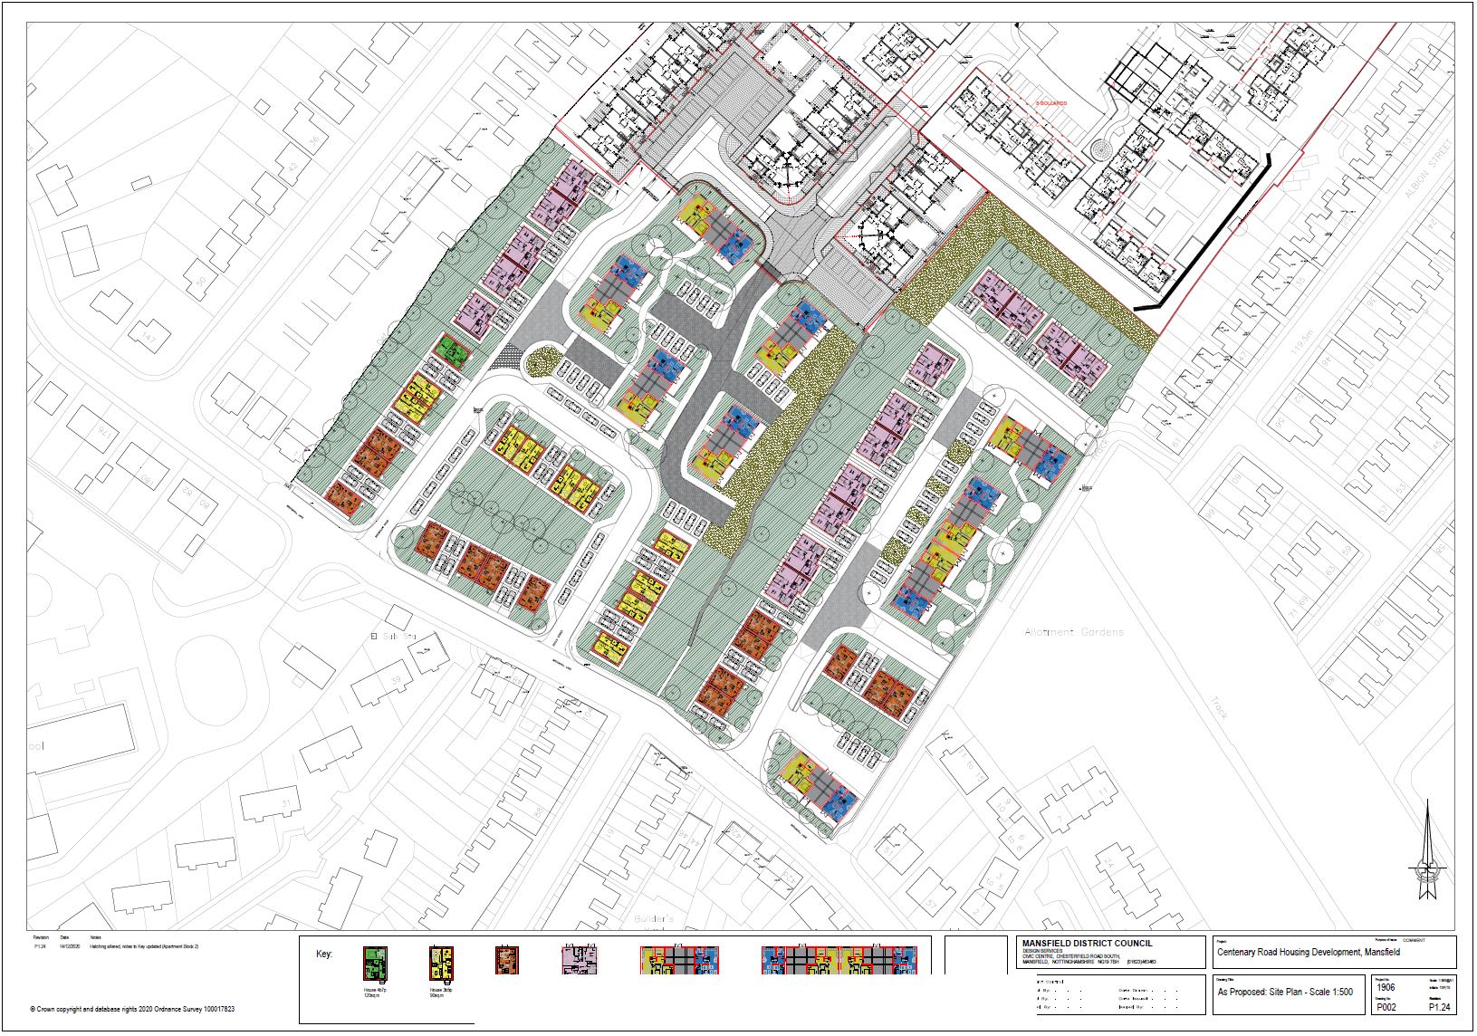
Appendix 2 – Long Term Cashflow

